**Title**

|  |  |  |
| --- | --- | --- |
| **Abstract** |  | **Research Article**  **Article History**  Received :  Accepted :  **Keywords** |

**1. Introduction**

The introduction should briefly place the study in a broad context and highlight why it is important. It should define the purpose of the work and its significance. The current state of the research field should be carefully reviewed, and key publications cited. Please highlight controversial and diverging hypotheses when necessary. Finally, briefly mention the main aim of the work and highlight the principal conclusions. As far as possible, please keep the introduction comprehensible to scientists outside your particular field of research. (Nizhny Tagil Tüzüğü, 2003; Köksal ve Ahunbay, 2006).

**2. Material and Methods**

The Materials and Methods should be described with sufficient details to allow others to replicate and build on the published results. Please note that the publication of your manuscript implies that you must make all materials, data, computer code, and protocols associated with the publication available to readers. Please disclose any restrictions on the availability of materials or information at the submission stage. New methods and protocols should be described in detail while well-established methods can be briefly described and appropriately cited.

**3. Results and Discussion**

This section may be divided by subheadings. It should provide a concise and precise description of the experimental results, their interpretation, as well as the experimental conclusions that can be drawn.

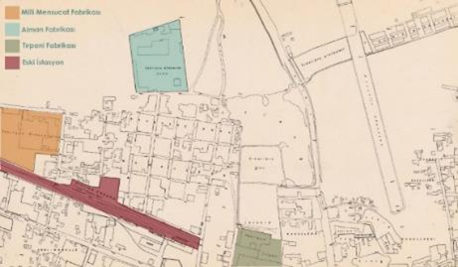

**Figure 1.** This is a figure

**Table 1**. This is a table

|  |  |  |
| --- | --- | --- |
| Data | Data | Data |

**4. Conclusions**

Authors should discuss the results and how they can be interpreted from the perspective of previous studies and of the working hypotheses. The findings and their implications should be discussed in the broadest context possible. Future research directions may also be highlighted. Authors can combine results and discussion if they wish.

**References**

Akpolat, M., 2004. A section of Ottoman Architecture after Tanzimat: Adana-Mersin railway station buildings. *Hacettepe University Faculty of Letters Journal*, 21(1): 77-85.

Anonymous, 2023a. Old Gin Factory. (https://www.kucuksaat.com/seyhanda-eski-circir-fabrikasi-25-milyonluk-yatirimla-sanat-merkezine donusuyor-27778h.htm), (Access date: 20.04.2023).

Biber, K., İslamoğlu, Ö., 2023. Reuse of historical buildings: The example of Nemlizade Mansion. *Artium Journal*, 11(1): 33-42.

Büyükarslan, B., Güney, D.E., 2013. The process of re-functioning industrial heritage buildings and the example of Istanbul Salt Warehouse. *Beykent University Journal of Science and Engineering*, 6(2): 31-58.